DEVOPS ASSIGNMENT – 1

1. What does WSL stand for? a. Windows Software Locator b. Windows System for Linux c. Windows Subsystem for Linux d. Windows Shell Launcher  
   Ans: c
2. Which Linux command is used to navigate to the home directory of the current user? a. cd / b. cd ~ c. cd .. d. cd home  
    Ans: b
3. What is the default package manager for most Linux distributions? a. Yum b. Apt c. RPM d. DNF  
   Ans: b
4. Which OSI model layer is responsible for routing and forwarding data packets? a. Application layer b. Transport layer c. Network layer d. Data link layer  
   Ans: c
5. What is the purpose of a subnet mask in networking? a. It identifies the host within a subnet. b. It defines the range of IP addresses in a network. c. It encrypts data for secure transmission. d. It specifies the DNS server for a network.  
   Ans: b
6. Which Linux command is used to create a new directory? a. touch b. mkdir c. cp d. rm  
   Ans: b
7. What is the primary role of a shell in a Linux environment? a. Managing hardware resources b. Running GUI applications c. Providing a command-line interface d. Handling network requests  
   Ans: c
8. Which of the following is NOT a Linux distribution? a. Ubuntu b. Apache c. CentOS d. Fedora  
   Ans: b
9. In networking, what does the acronym DNS stand for? a. Dynamic Network Server b. Domain Name System c. Data Networking Service d. Distributed Network Security  
   Ans: b
10. Which Linux command is used to display the contents of a file? a. cat b. grep c. ls d. cp  
    Ans: a

**TASKS:**  
Task: Use the **ls** command to list all files and directories in your home directory.

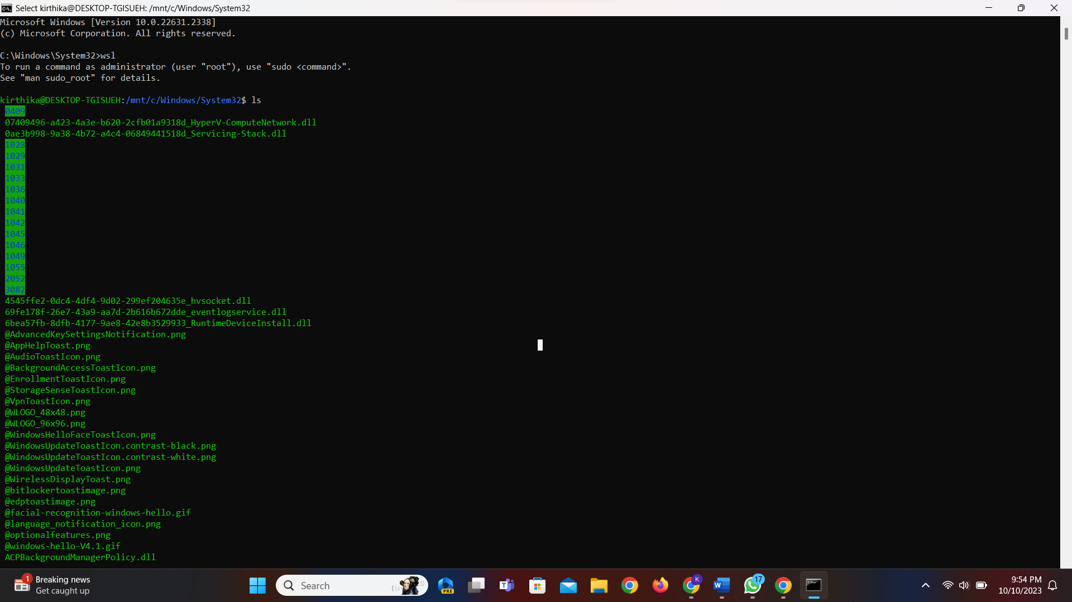  
  
Task: Create a new directory called "Documents" within your home directory  
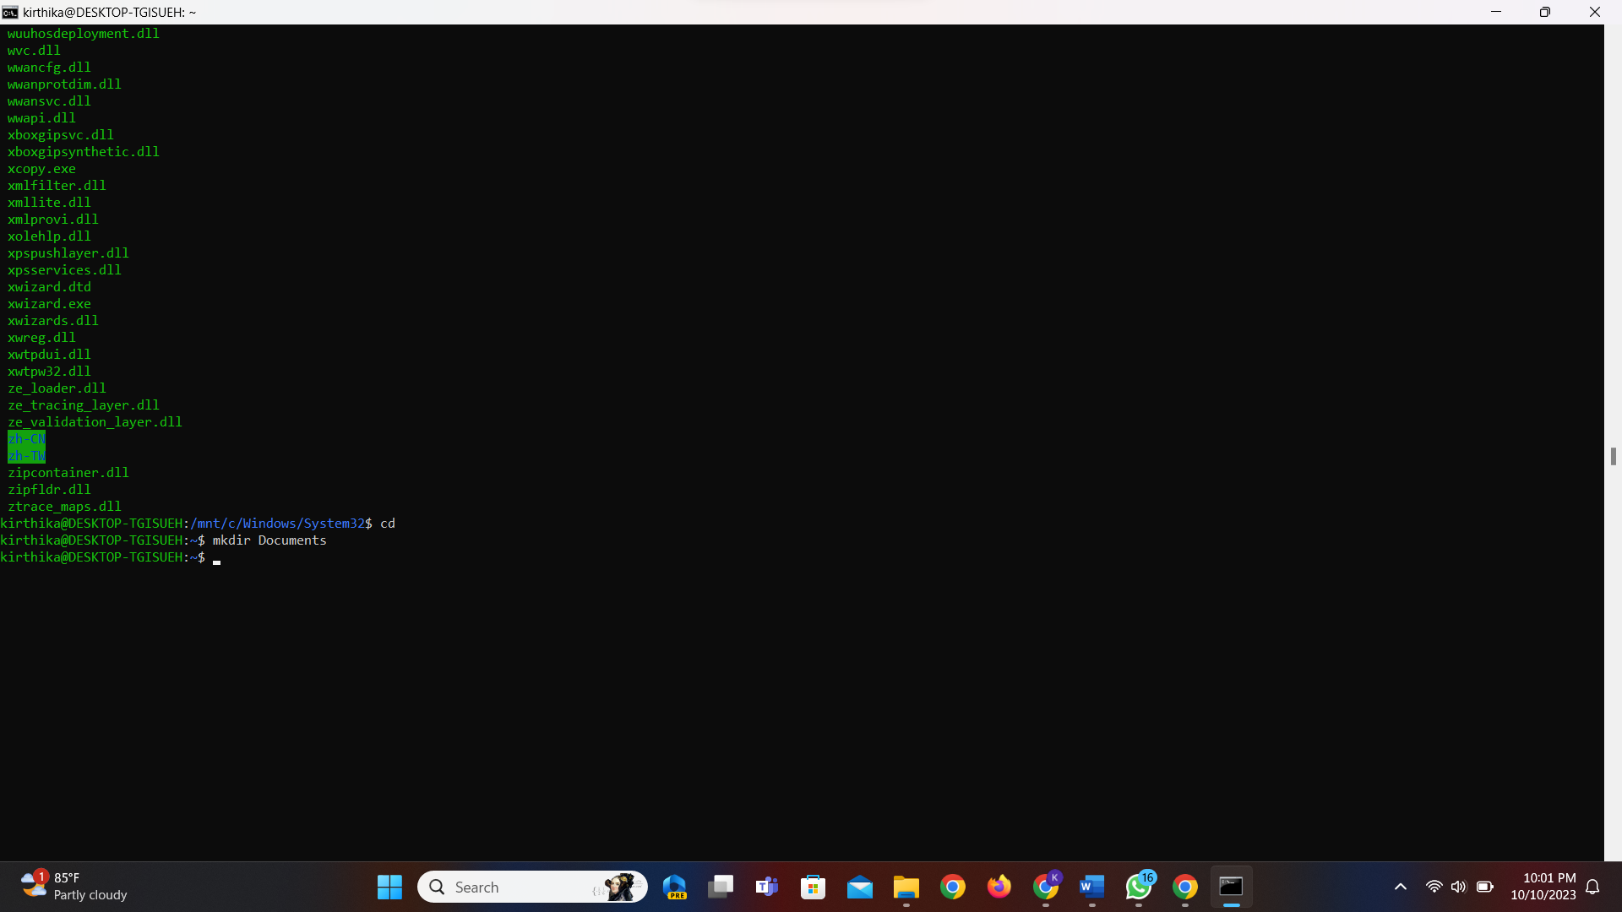  
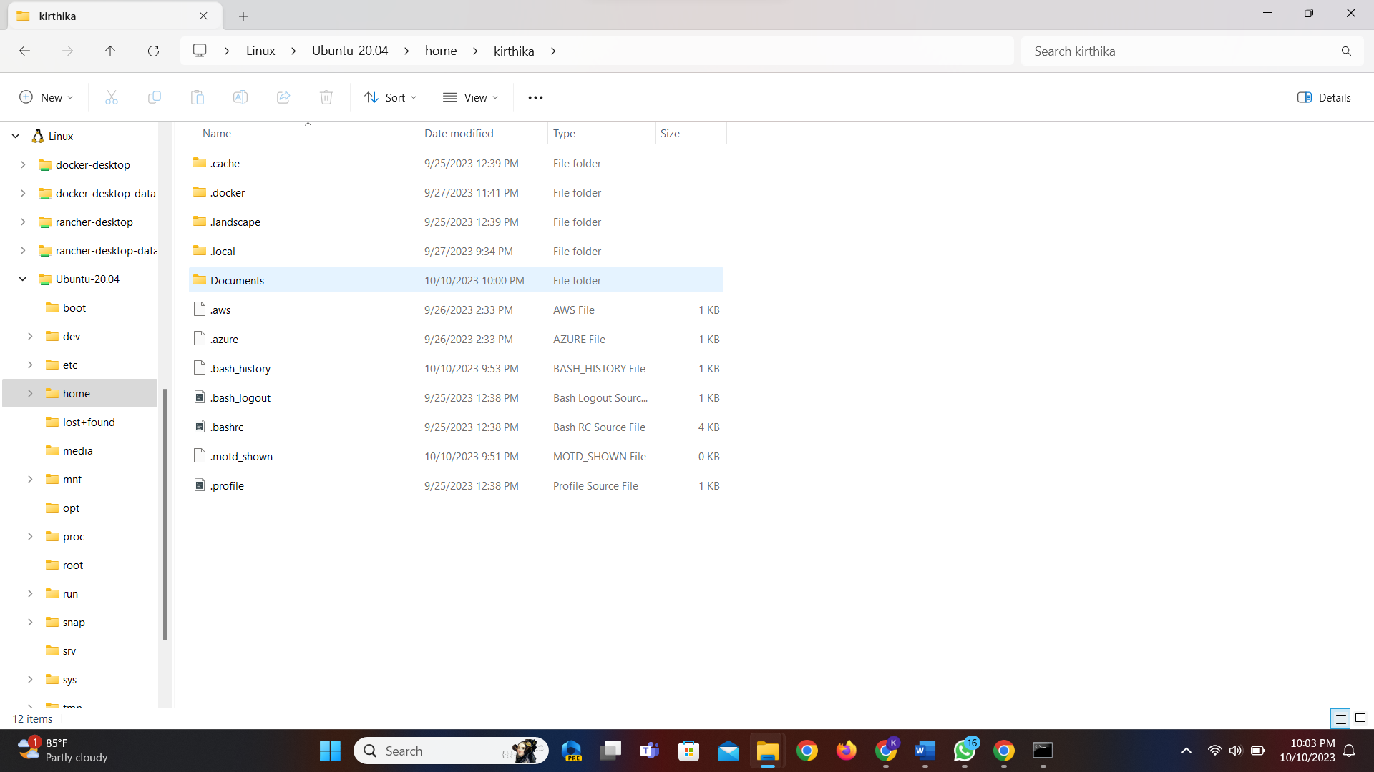  
  
Task: Change the permissions of a file named "myFile.txt" to allow read and write access for the owner, and read-only access for others  
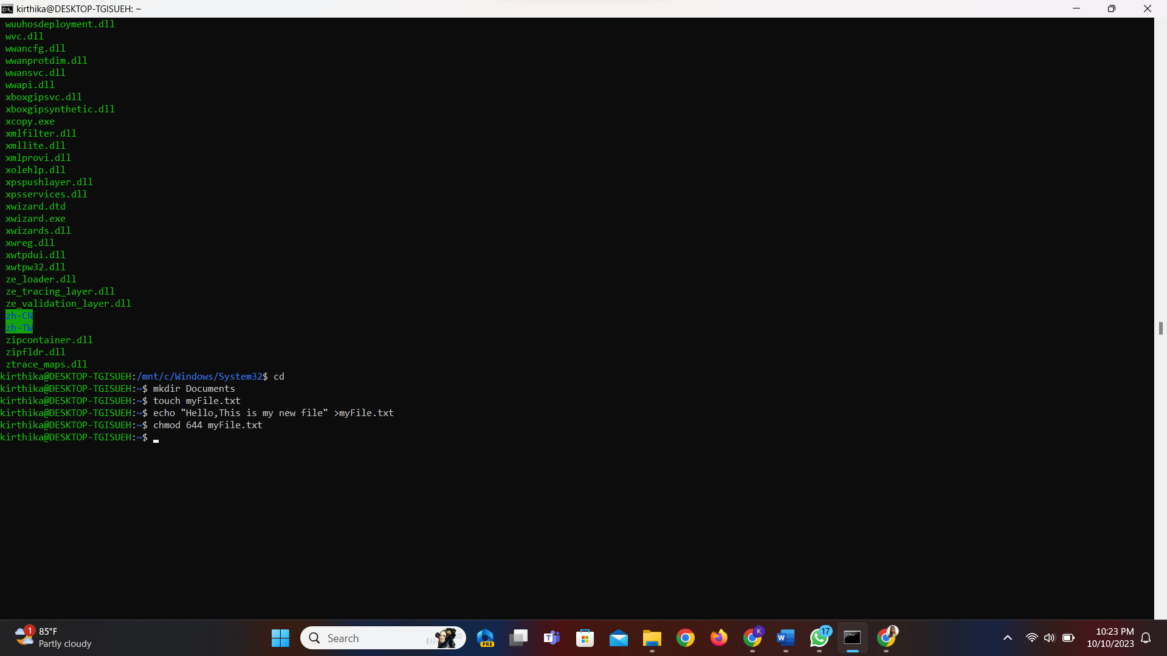

Task: Install a text editor of your choice on your Linux system using the appropriate package manager  
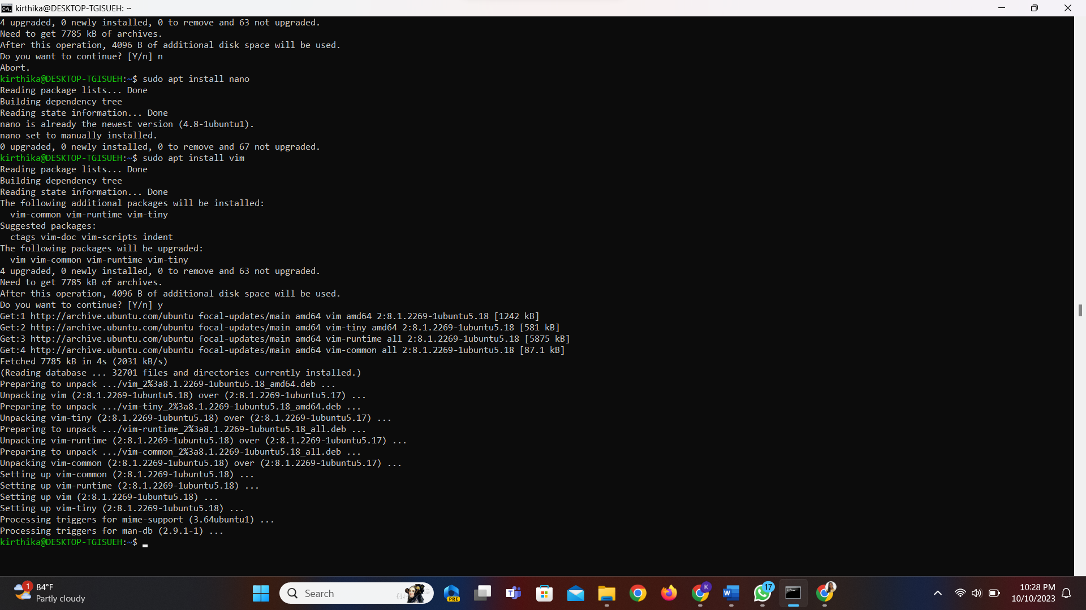

Task: Configure your Linux system to use Google's DNS servers (8.8.8.8 and 8.8.4.4) for DNS resolution  
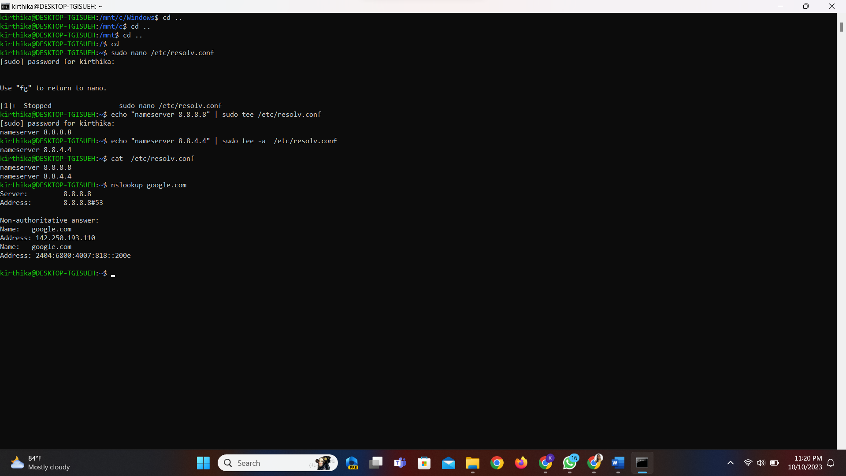

Task: Set up a static IP address (e.g., 192.168.1.100) on your Linux machine using the command line  
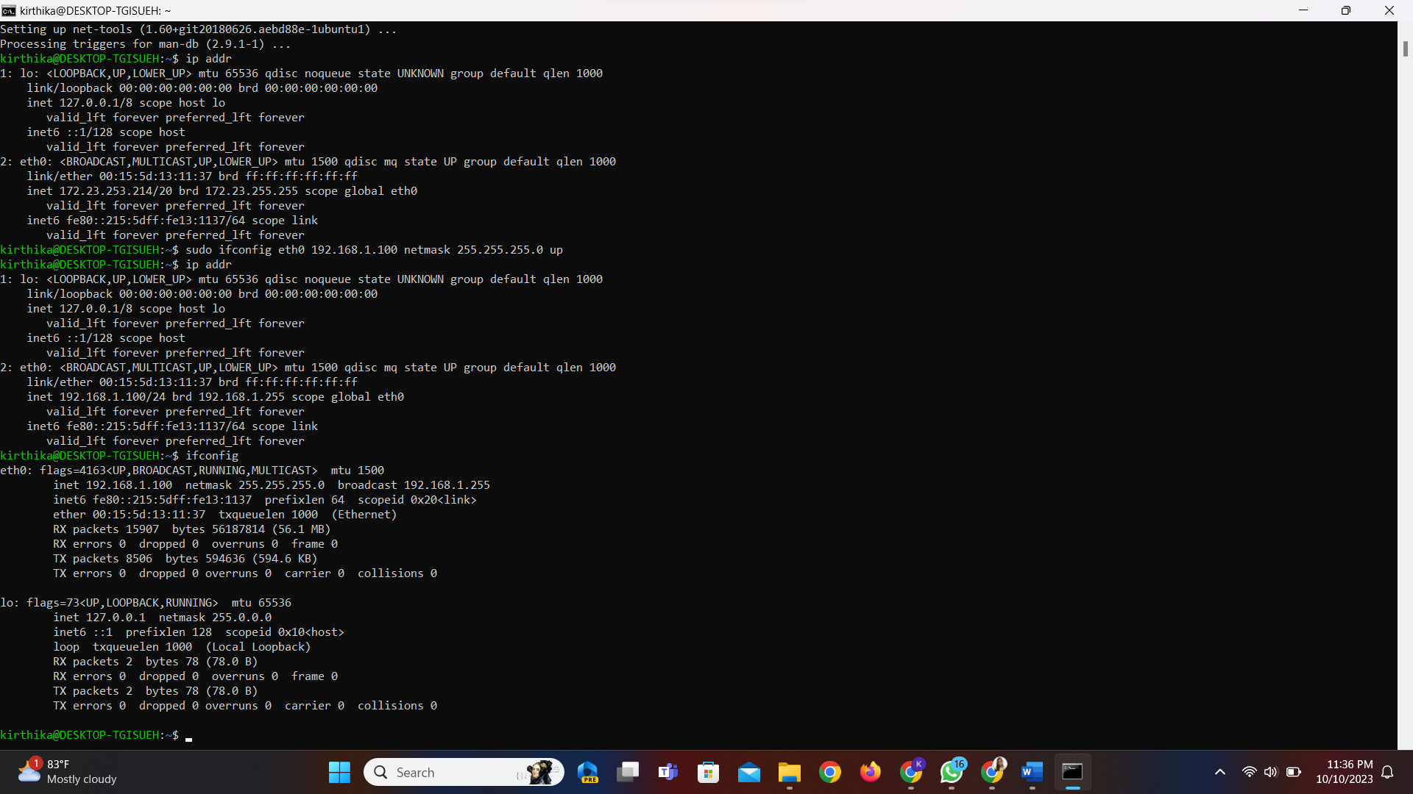

Task: Create a simple bash script that prints "Hello, World!" when executed  
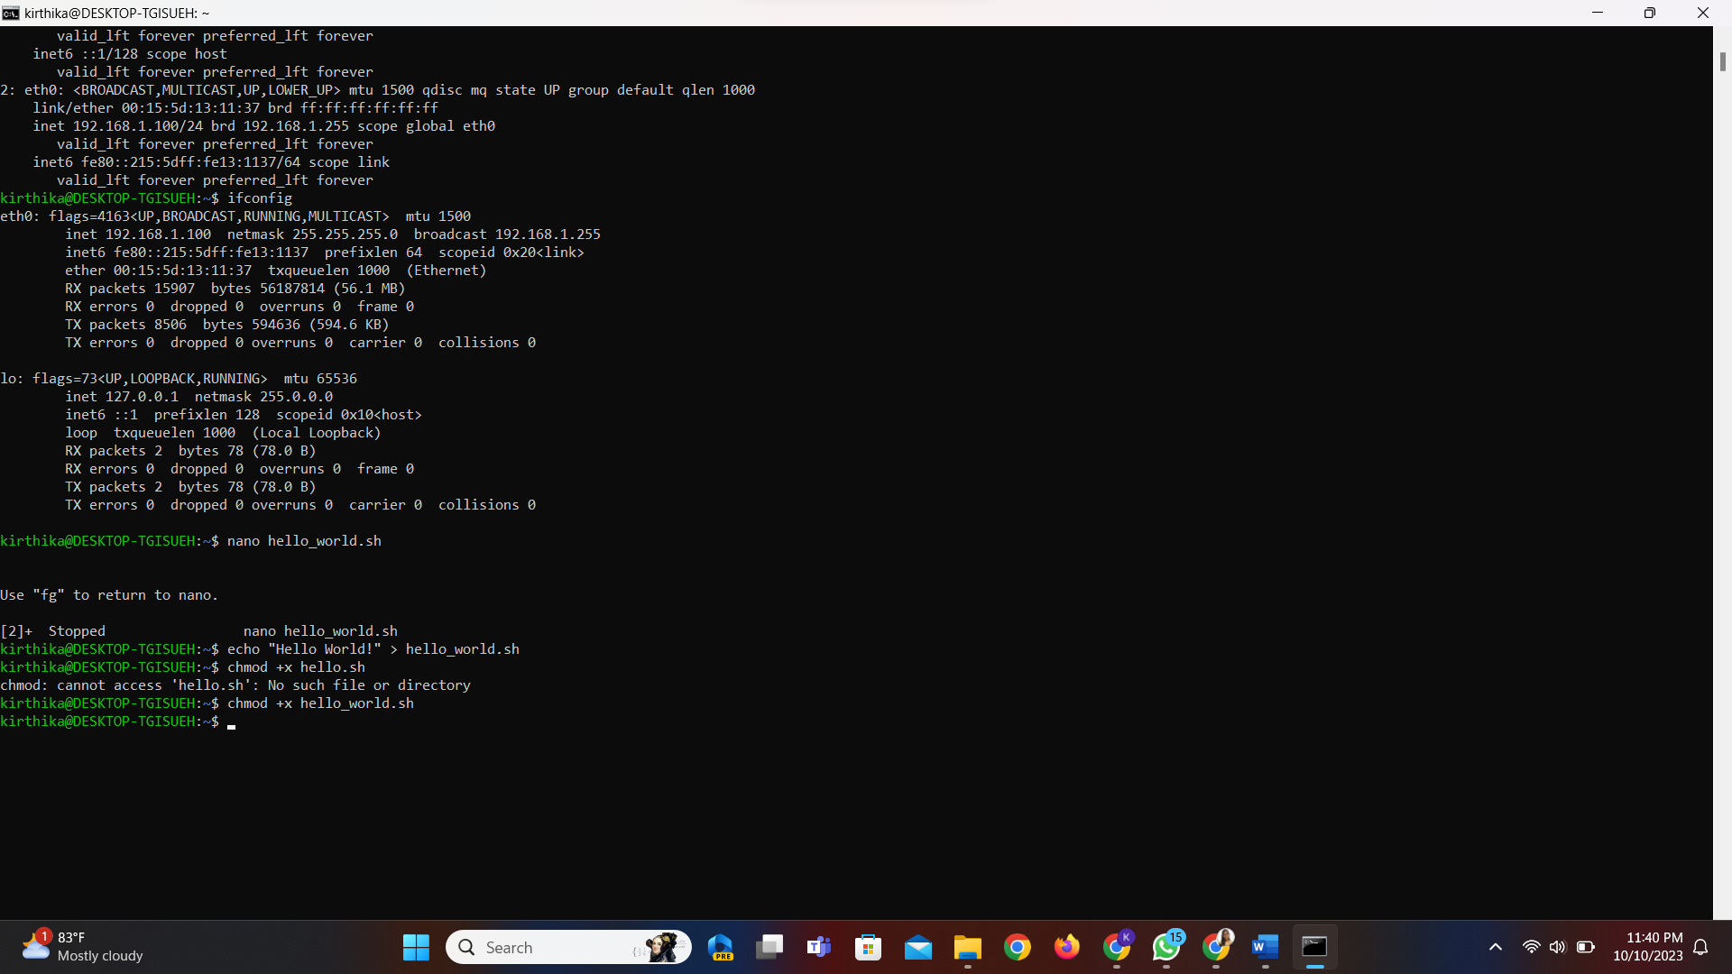

Task: Use the **ping** command to check the connectivity to a remote server or website (e.g., "ping [www.example.com](http://www.example.com/)").  
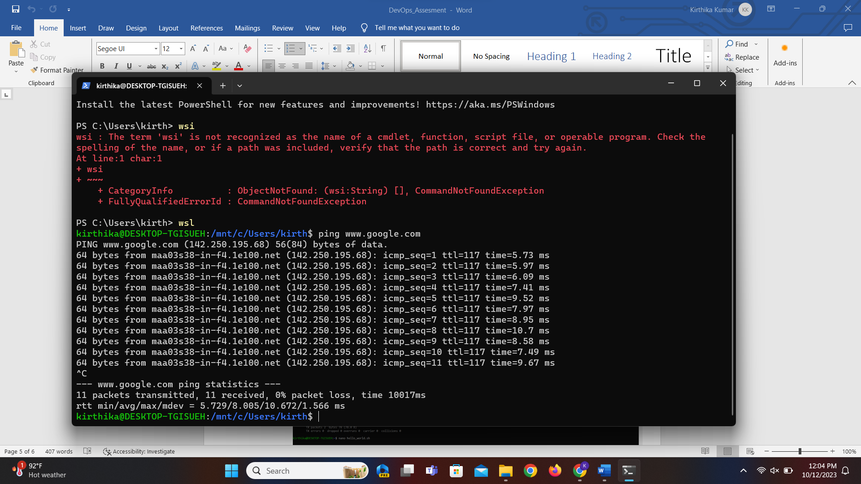

Task: Create a symbolic link named "mylink" that points to a file named "targetfile.txt."

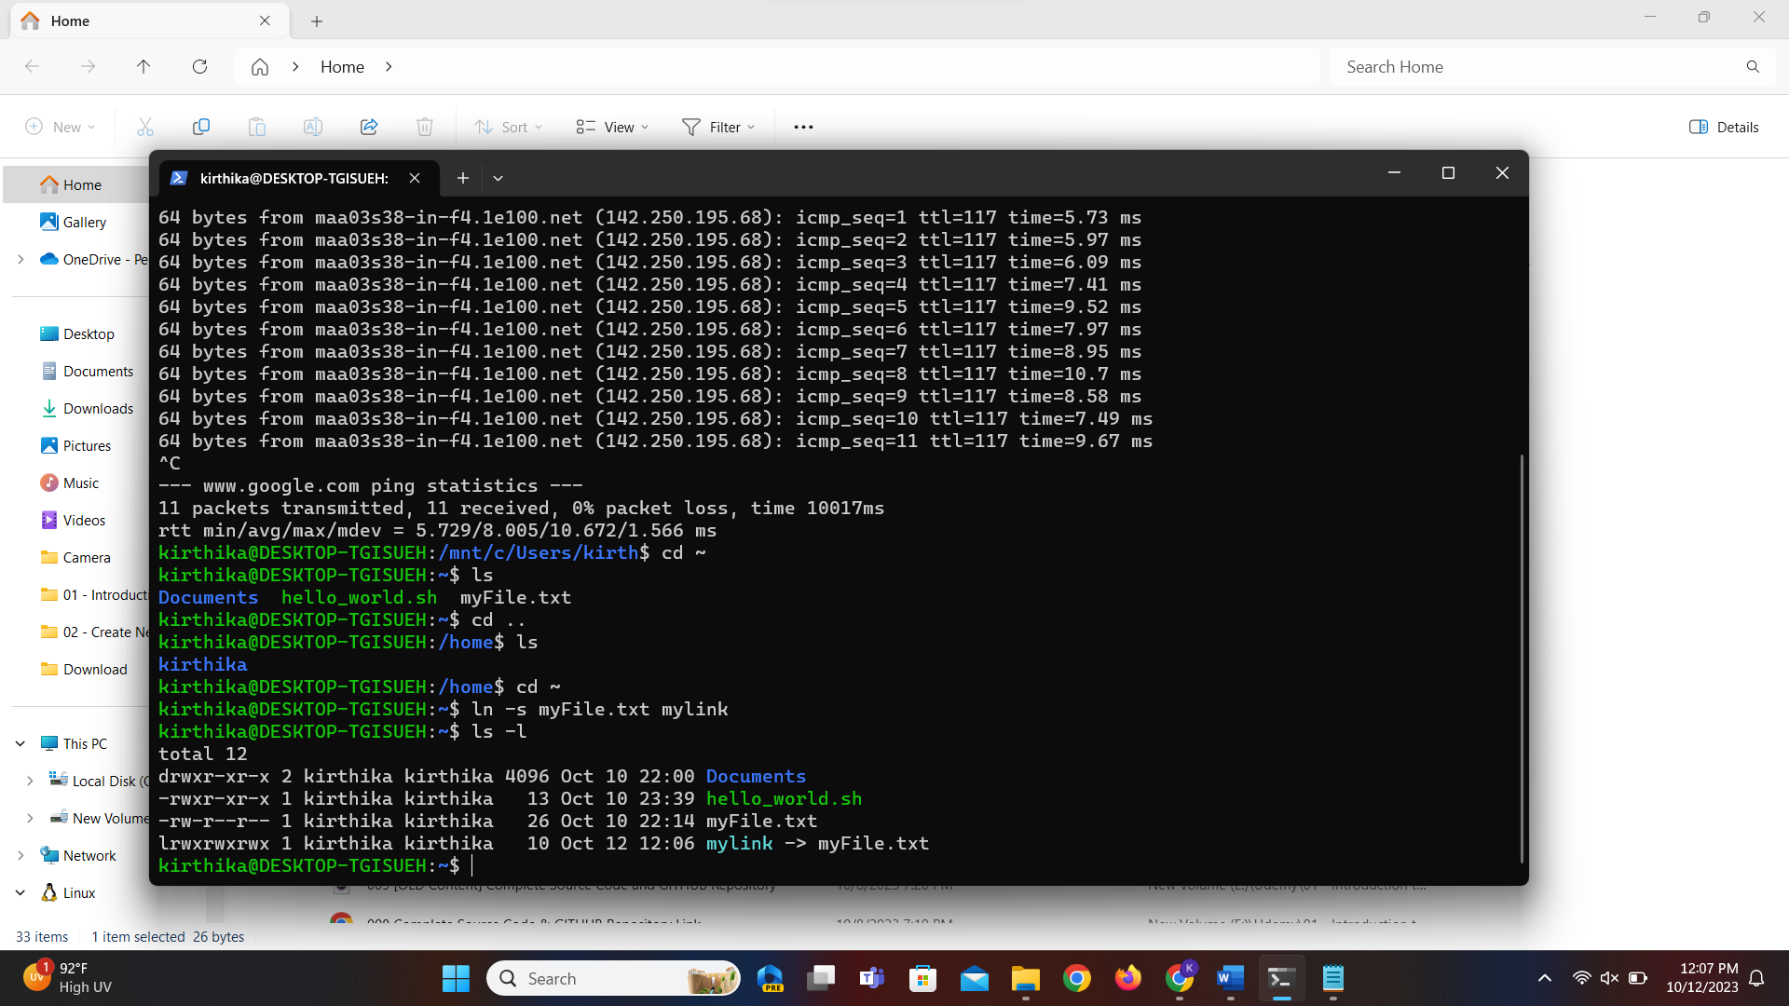

Task: Use the **netstat** command to display a list of open network connections on your Linux machine.  
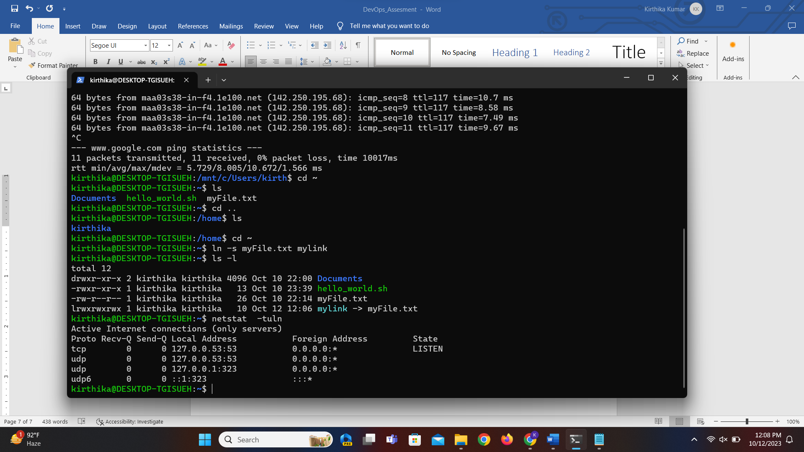

**LABS:**

Lab 1: WSL Installation

1. Objective: Install Windows Subsystem for Linux (WSL) on your Windows machine.

2. Steps: Document the installation process, and launch a Linux distribution through WSL

Step 1 : Open Microsoft Store

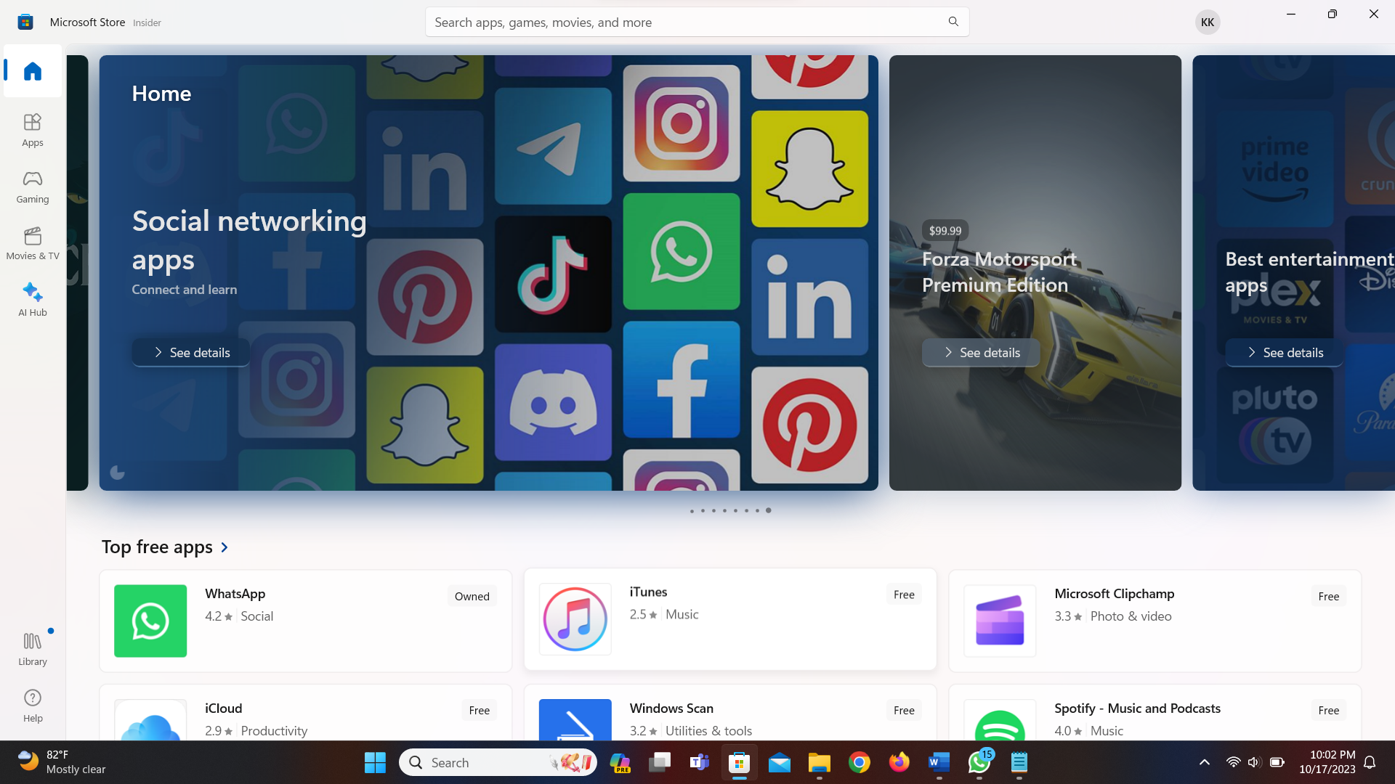

Step 2 : Install Windows Subsystem for Linux

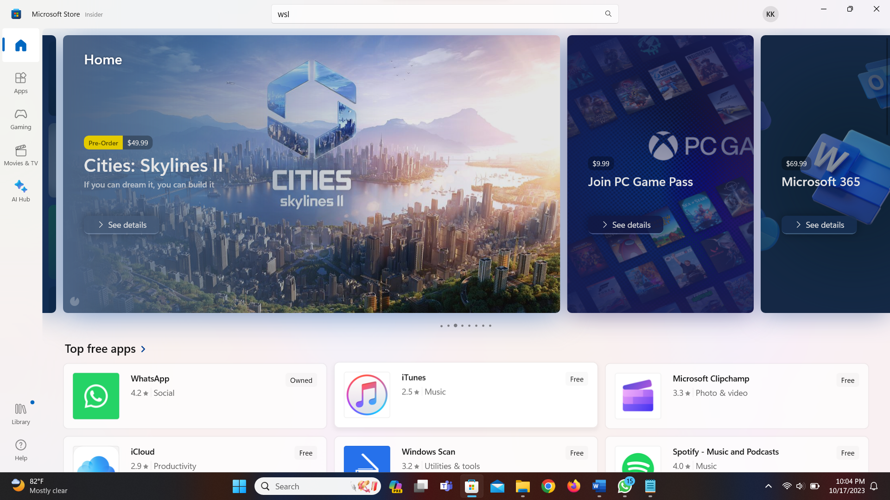

Step 3 : Install Ubuntu

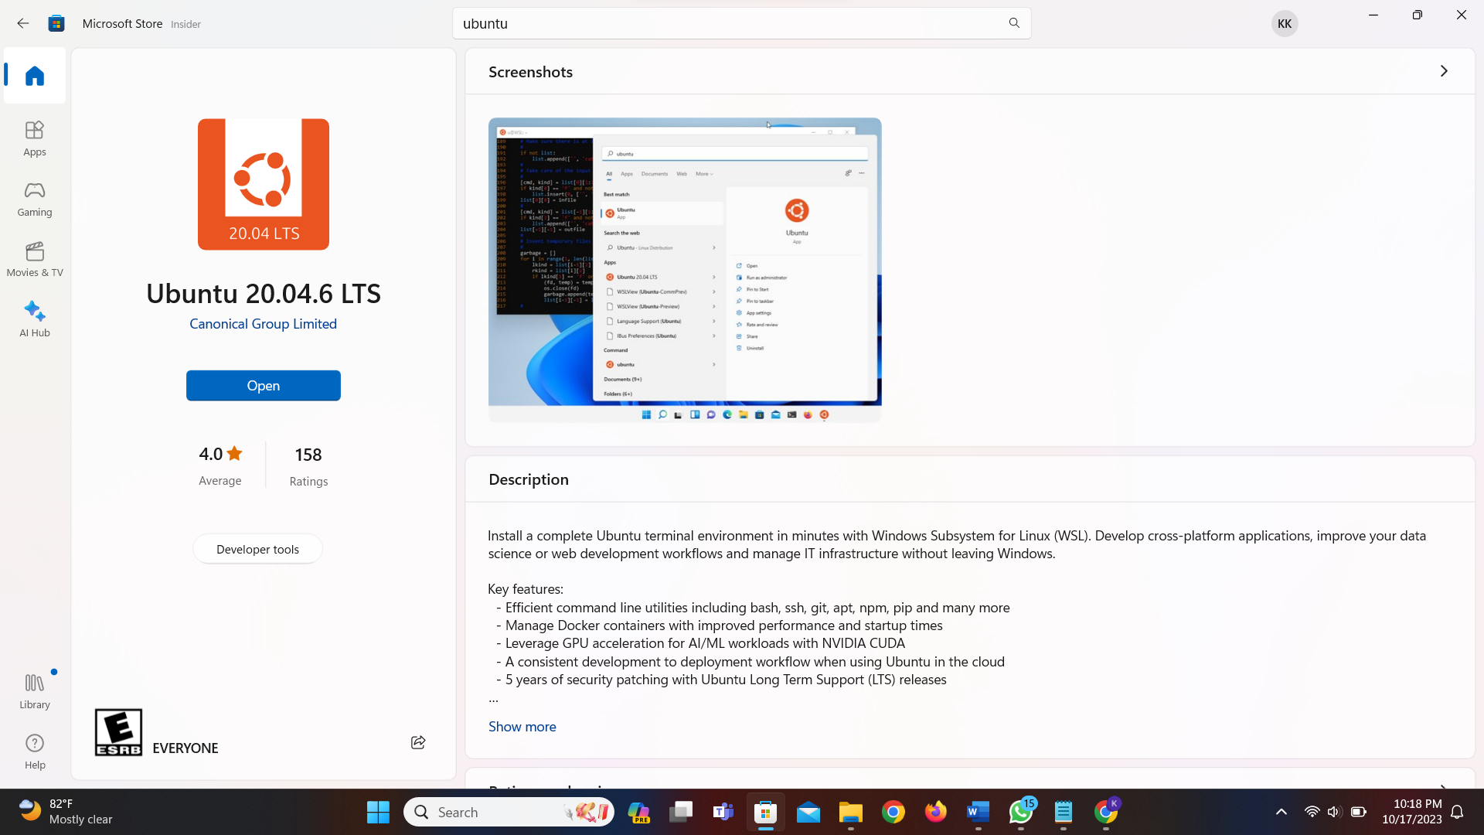

After installation, it will ask for username and password. I have created the username and password.

Here is the version of wsl

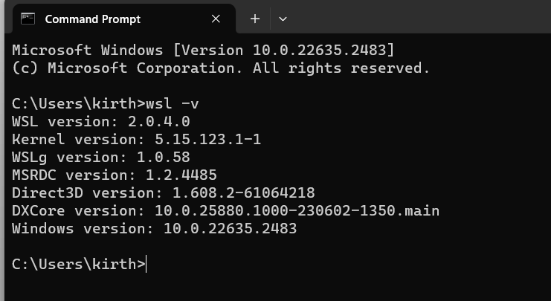

Lab 2: Basic Linux Commands

1. Objective: Practice basic Linux commands such as ls, cd, mkdir, and touch in a Linux terminal.

2. Steps: Execute these commands and describe their outcomes.

**ls** – list files and directories in current directory



**cd** – change directory

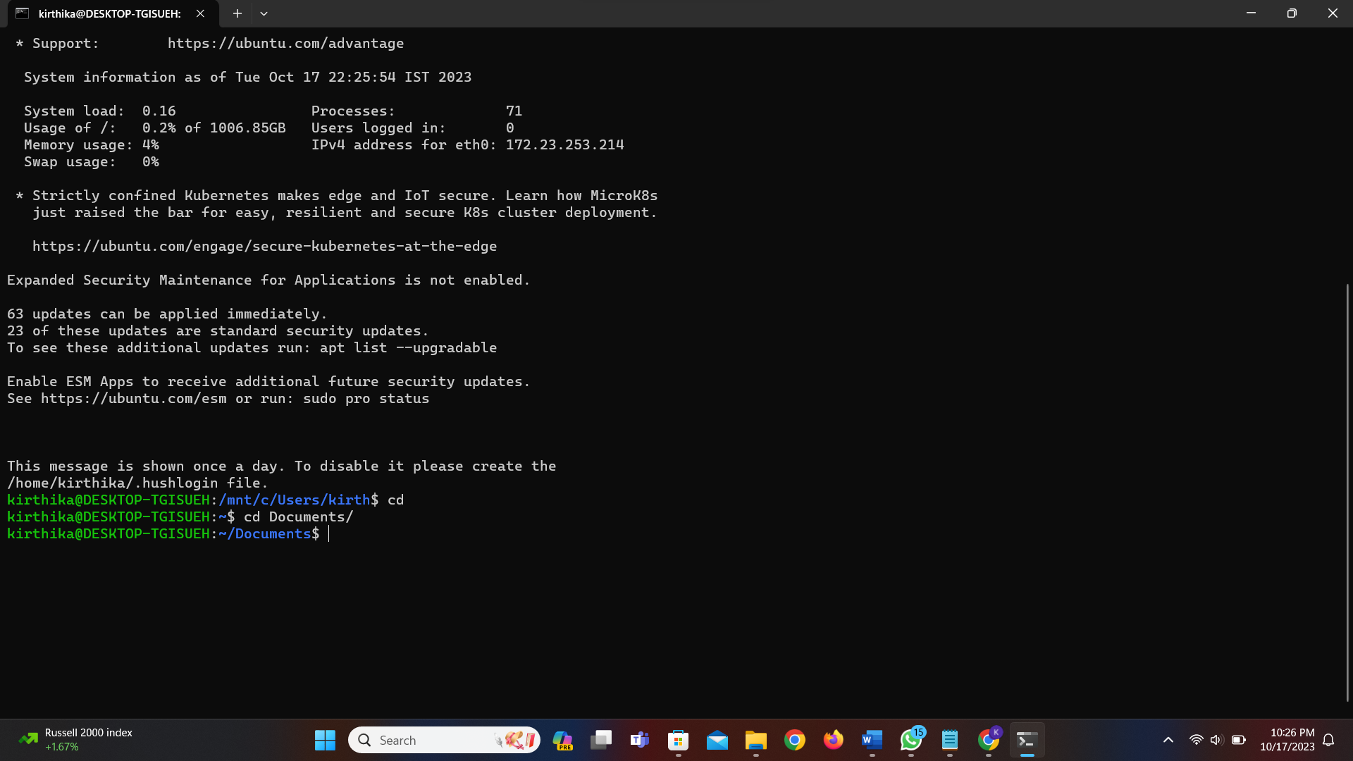

**mkdir** – make directory



**touch** – create an empty file with the specified name



Lab 3: Network Configuration

1. Objective: Configure your Linux machine to use a static IP address and Google's DNS servers.

2. Steps: Document the configuration steps and test network connectivity.





Lab 4: File Permissions

1. Objective: Explore file permissions by creating files and directories with different permissions settings.

2. Steps: Create and modify files with various permission settings, and describe the results.

Create a file and write into it:

Change its permission:



Lab 5: Bash Scripting

1. Objective: Write a bash script that automates a task of your choice.

2. Steps: Create the script, execute it, and explain its functionality.

Create bash file:



Write script in sample.sh

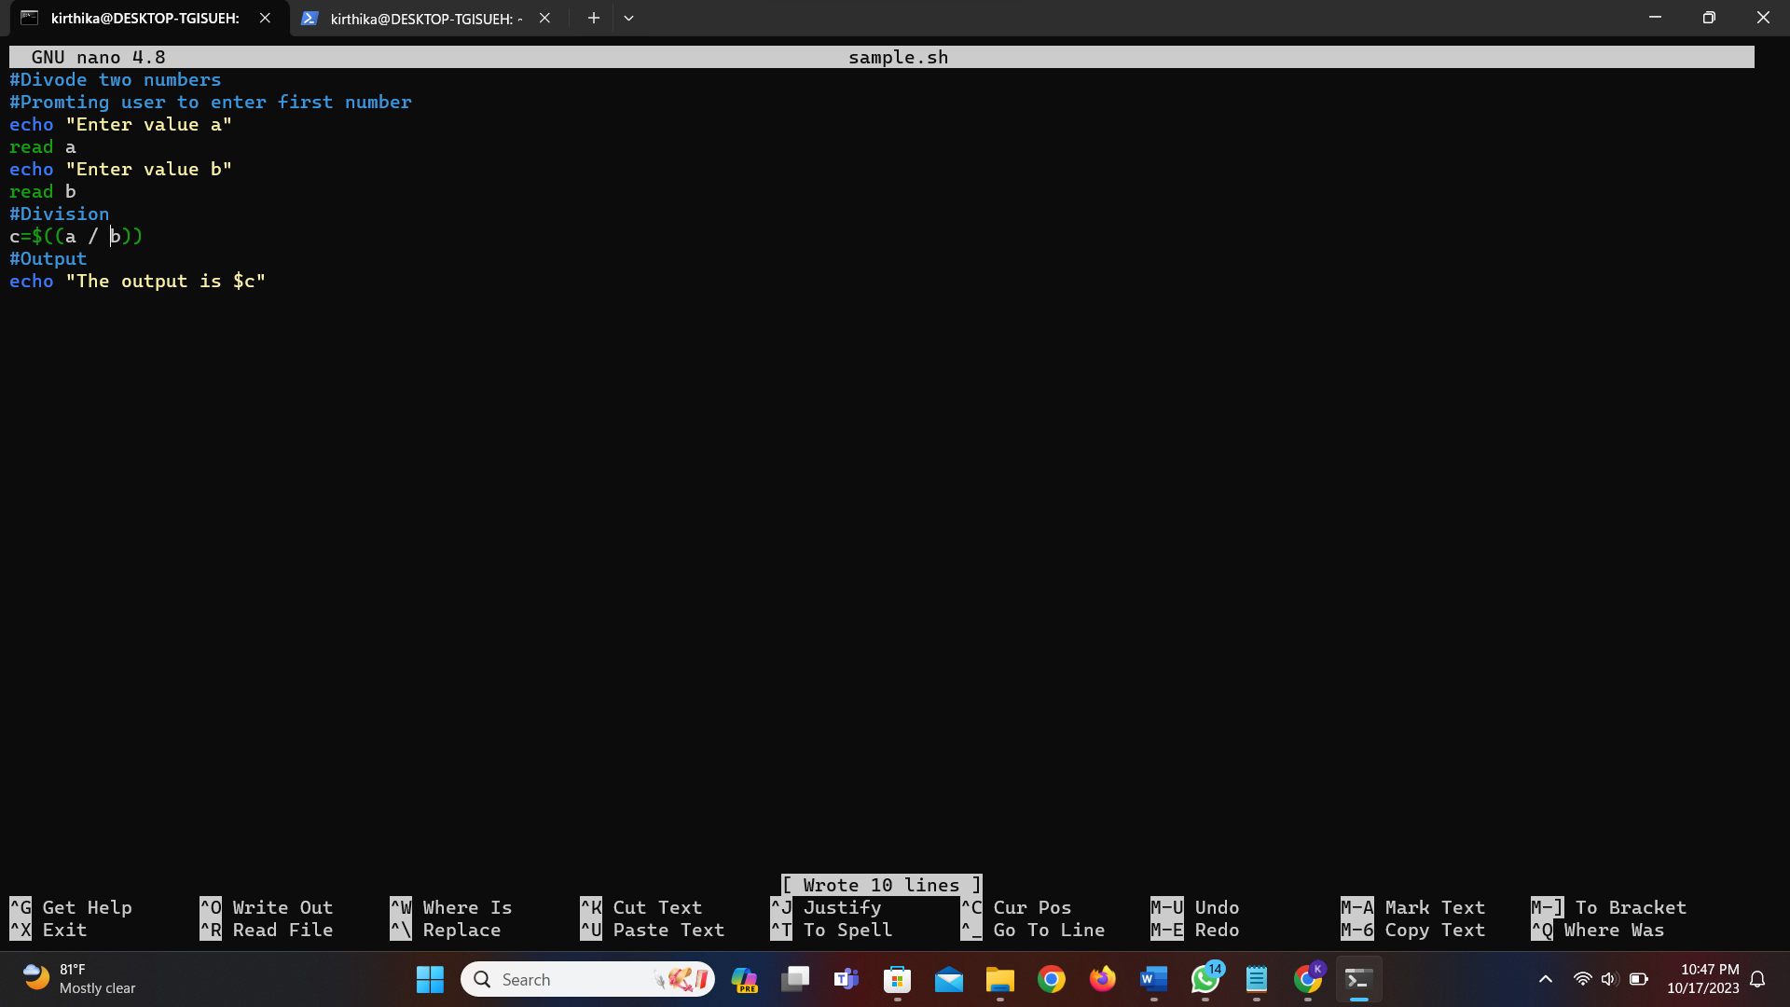

Save and run in terminal:

